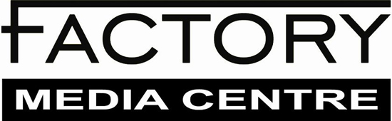
CALL FOR APPLICATIONS: WORKSHOP INSTRUCTORS
Deadline: Monday, November 6, 2017

Factory Media Centre is looking to expand its current roster of contract workshop instructors. We are asking mid-career and established media artists, independent filmmakers, visual artists, writers, videographers, audio technicians, and industry professionals to bring their work and expertise to our attention. While workshop instruction is not regular work, qualified persons will be added to our instructor database and invited to plan and facilitate occasional workshops at FMC when needed. Workshop instructors are compensated for their work as artist-facilitators based on CARFAC standards.

FMC is committed to equity in all aspects of its operations. We encourage applications from indigenous people, persons with disabilities, ethnic or racial minorities, immigrants and refugees, Francophones, LGBTQI+ persons, women, and persons of all socio-economic walks of life.

Interested persons should complete this application form and send it along with their current CV and 2-3 samples of their work as attachments or links to info@factorymediacentre.ca with the subject line “LastName_Workshop Instructor Application.”

Please note: Due to the number of application we receive, only successful applicants will be contacted.

FACTORY MEDIA CENTRE – WORKSHOP INSTRUCTOR APPLICATION FORM

Full Name:
Email: Phone:
Mailing Address: City, Postal Code:
Website/ Portfolio:

Are you a current Factory member? yes no
What is your professional background (i.e. media artist, filmmaker, etc.)?
What discipline(s) do you work with most often (i.e. film, audio, cinematography, performance etc.)?
Do you have experience in the artist-run sphere? yes no
Do you have experience as an instructor? yes no
Do you have experience in teaching children or youth? yes no
Which of the following topics would you feel confident and comfortable teaching at all levels (beginner, intermediate, advanced)? Select all that apply.

Adobe Photoshop
Adobe Illustrator
Adobe After Effects
Adobe Flash
Adobe Audition
Adobe Premiere Pro
Adobe Media Encoder
Adobe Lightroom
Final Cut Pro
SuperCollider
Max MSP
SketchUp
Cubase Elements
Celtx
Dragonframe
Reaper
Other (software). Please list:

Concept development
Proposal Writing
Scriptwriting
Grant Writing
Budgeting
WordPress
Social Media Marketing
Film Distribution
Securing Sponsorships
Income Tax for Artists
Other (development). Please list:

Sound Art
Low-budget Audio
Multi-channel Audio
Sound Recording
Voice-over
Other (audio). Please list:

Illustration
Graphic Design
Interactivity
Lighting
Photography
Video and Film
Multi-channel Video
Documentary Filmmaking
Music Videos
Installation
Projection Mapping
Performance
Performance and Digital Media
Green Screen
360 Video
Digital SLR
Cinematography
Camera Raw
Photo Manipulation
Hand Drawn Animation
2D Animation
3D Animation
Live-Coding
Arduino Coding
HTML
Other. Please list:

Please list any other ideas you have for workshop topics:

Do you have a Vulnerable Sector Police Check? yes no
If no, are you willing to obtain one? yes no
Anything else you would like us to know?

